**Topics: Confidence Intervals**

1. For each of the following statements, indicate whether it is True/False. If false, explain why.
2. The sample size of the survey should at least be a fixed percentage of the population size in order to produce representative results.

Ans) **True**, The sample size should be fixed percentage of the population size.

The representation of the survey result should have a sample size.

1. The sampling frame is a list of every item that appears in a survey sample, including those that did not respond to questions.

Ans) **False**, The sampling frame only includes the list of item that responds to the question. It doesn’t include the data which doesn’t respond to the question.

1. Larger surveys convey a more accurate impression of the population than smaller surveys.

Ans) **True,** larger surveys survey more accurate impression, As larger

surveys involve larger sample size which leads to reduction of error.

1. *PC Magazine* asked all of its readers to participate in a survey of their satisfaction with different brands of electronics. In the 2004 survey, which was included in an issue of the magazine that year, more than 9000 readers rated the products on a scale from 1 to 10. The magazine reported that the average rating assigned by 225 readers to a Kodak compact digital camera was 7.5. For this product, identify the following:
2. The population

Ans) All the magazine readers ( i.e more than 9000 readers).

1. The parameter of interest

Ans) The mean of the population which rated the product.(i.e rating of the camera)

1. The sampling frame

Ans) All the readers.

1. The sample size

Ans) 225 readers.

1. The sampling design

Ans) Simple random sampling.

1. Any potential sources of bias or other problems with the survey or sample

Ans) potential bias may be 225 readers are participated out of more than 9000 readers. As lesser sample accuracy of the data will be lower. This may result in error

1. For each of the following statements, indicate whether it is True/False. If false, explain why.
2. If the 95% confidence interval for the average purchase of customers at a department store is $50 to $110, then $100 is a plausible value for the population mean at this level of confidence.

Ans) **True**, confidence interval identifies the collection of values for the population parameter that are consistent with observed sample.

1. If the 95% confidence interval for the number of moviegoers who purchase concessions is 30% to 45%, this means that fewer than half of all moviegoers purchase concessions.

Ans) **False**, we have evidence in that direction but we cannot confirm 100% based on the data. We have considered value out of this range(i.e more than 95% of confidence interval).

1. The 95% Confidence-Interval for *μ* only applies if the sample data are nearly normally distributed.

Ans) **False**, we should have moderately large sample.

1. What are the chances that ?
2. ¼
3. ½
4. ¾
5. 1

Ans) **B. ½ ,** this is pure assumption . there is 50% chance that the sample mean is

greater than population mean.

1. In January 2005, a company that monitors Internet traffic (WebSideStory) reported that its sampling revealed that the Mozilla Firefox browser launched in 2004 had grabbed a 4.6% share of the market.
2. If the sample were based on 2,000 users, could Microsoft conclude that Mozilla has a less than 5% share of the market?

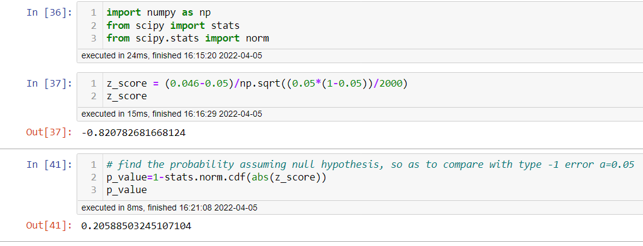

P value > 0.05 so we accept null hypothesis i.e. Mozilla has more than 5% shares.

1. WebSideStory claims that its sample includes all the daily Internet users. If that’s the case, then can Microsoft conclude that Mozilla has a less than 5% share of the market?

Ans) in this case, we have data on the entire population and the sample value accurately reflects the number of population. Thus we can conclude that share is less than 5%.

1. A book publisher monitors the size of shipments of its textbooks to university bookstores. For a sample of texts used at various schools, the 95% confidence interval for the size of the shipment was 250 ± 45 books. Which, if any, of the following interpretations of this interval are correct?
2. All shipments are between 205 and 295 books.

Ans) **Incorrect,** the interval of 205-295 is for 95% not 100%.

1. 95% of shipments are between 205 and 295 books.

Ans) **Incorrect,** the interval doesn’t describes individual shipment.

1. The procedure that produced this interval generates ranges that hold the population mean for 95% of samples.

Ans) **Correct,**95% of intervals created in this way contained the true population mean

1. If we get another sample, then we can be 95% sure that the mean of this second sample is between 205 and 295.

Ans) **Incorrect,** the interval doesn’t describes the mean of another sample.

1. We can be 95% confident that the range 160 to 340 holds the population mean.

Ans) **Incorrect,** the interval doesn’t corresponds to the 95% confidence level.

1. Which is shorter: a 95% *z*-interval or a 95% *t*-interval for *μ* if we know that σ =s?
2. The z-interval is shorter
3. The t-interval is shorter
4. Both are equal
5. We cannot say

Ans) **A. The z-interval is shorter.**

Questions 8 and 9 are based on the following: To prepare a report on the economy, analysts need to estimate the percentage of businesses that plan to hire additional employees in the next 60 days.

1. How many randomly selected employers (minimum number) must we contact in order to guarantee a margin of error of no more than 4% (at 95% confidence)?
2. 600
3. 400
4. 550
5. 1000

Ans) **A. 600,**

Margin of error of estimate = 1/sqrnt(n)

0.04 = 1/sqrt(n)

n = 252 = 625

so we can take it as 625.

1. Suppose we want the above margin of error to be based on a 98% confidence level. What sample size (minimum) must we now use?
2. 1000
3. 757
4. 848
5. 543

Ans) **C. 848**